The Physics and Mathematics of MRI Gradient Nonlinearity Distortion

1. Scope 2
2. Background 2
What is MRI? 2
Hardware Components of an MRI Scanner 2
Physics of Signal Formation and Detection 3
RF Excitation and Resonance 4
Principle of Spatial Localization with Gradient Fields and Frequency Encoding 4
One-Dimensional Imaging Equation, Fourier Transform, and k-Space 5
The 3D Imaging Equation 6
2D Image Representation 7
3D Coverage: 3D Imaging versus Multi-sice 2D Imaging 7
3. Gradient Field Nonlinearities as a Warping Transformation 8
Origin and Manifestations 8
Mathematical Description of the Distortion in One Dimension 9
4. Further Details on Physics and Mathematics of Gradient Nonlinearity Distortion 10
The Gradient Coils 10
Physical and Mathematical Description of Nonlinear Gradient Fields 11
5. Inversion of the Distortion Transformation 12
References 12

1. Scope
This document provides some information about the origin, mathematical description and correction of the gradient nonlinearity distortion in MRI. In chapter 2, we first describe the technical background of MRI in order to understand the origin of gradient nonlinearity distortions. In the third chapter we provide a general mathematical description of the nonlinearity distortion as a warping transformation. In chapter 4, we present more details on the physics and mathematics of the distortion, which will lead to an explicit mathematical description of the distortion transformation functions. Finally, in chapter 5 we will describe an iterative method to invert the distortion transformation in order to correct for it.

2. Background

What is MRI?
The image in MRI is a multidimensional data array representing the spatial distribution of nuclear magnetic properties of the image object although the original data acquired represents the frequency distribution of the responses of a multitude of hydrogen nuclei in an inhomogeneous magnetic field. The information is usually organized as 2D images, presented discretely in form of image pixels such that each pixel is a 2D representation of the measured physical quantity in the corresponding object voxel (a small 3D box).
The value of MR image pixels (or corresponding voxels) depends on many intrinsic physical parameters, including the nuclear spin density, ρ, the spin-lattice relaxation time T₁, the spin-spin relaxation time T₂, molecular motions (diffusion and perfusion), susceptibility effects, chemical shift differences, etc. The relative weight of these parameters in their contribution to the image contrast can be influenced by operator-selectable parameters, such as the repetition time TR, echo time TE, and flip angle α. However, this will not be further discussed here because it is not necessary or understanding and correcting the origin of gradient nonlinearity.

Hardware Components of an MRI Scanner
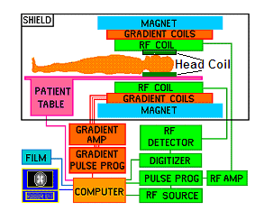
Fig. 1. Simplified block diagram of a typical MRI scanner.
The main components of the MRI scanner system are shown in Fig. 1. It consists of three main hardware components: the main magnet (blue), the gradient coil system (red), and the radiofrequency (RF) coil system (green). The main magnet can be thought of as a large tube, which fits inside the bore of the MR scanner. The housing of the three gradient coils also takes the form of a tube, which fit inside the main magnet. The RF body coil, which both produces and receives RF signals, takes the shape of another tube that fits inside the gradient coils. Hence the space in which the body part to be imaged is placed is a cylindrical volume with the longitudinal axis (z) being parallel to the patient longitudinal body axis and the diameter matching the inner diameter of the body coil housing. If the head is imaged, a removable RF head coil, which has a better signal to noise ratio than the body coil, is placed inside the body coil.

Physics of Signal Formation and Detection
The signal source in MRI is the macroscopic magnetization produced by excited nuclear spins in the imaged object. Spin is a fundamental quantum property of elementary particles just like electrical charge or mass, which is related to the angular momentum of the nucleus. In classical terms, angular momentum is due to spinning of an object about its axis. Spin quantum numbers come discrete, i.e., in multiples of ½, and can be either positive or negative. The total spin quantum number of paired protons and neutrons equals zero, while unpaired protons and neutrons in a nucleus each contribute a spin quantum number of ½. Thus, a nucleus with an uneven number of nucleons (protons or neutrons) has a nonzero spin quantum number, which is a multiple of ½, and a large number of them can, therefore, produce a net magnetization when placed in an external magnetic field. The most abundant nucleus with uneven number of nucleons in the human body is hydrogen with just one proton.
In MRI, an ensemble of nuclei of the same type, such as hydrogen, present in an object being imaged is called a nuclear spin system. Although nuclear spin is a property of the individual nucleus, characterized by quantum mechanics, with the large number of nuclei present in bulk matter, the bulk behavior of a spin system can be described in classical physics terms and the macroscopic magnetization is no longer discrete.
A single nucleus with a nonzero spin, such as hydrogen, creates a small magnetic field, which is represented by the vector quantity μ, called the nuclear magnetic moment. Spin angular momentum J and magnetic moment are linearly related to each other by
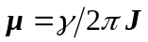 (1)
where γ is the gyromagnetic ratio, which for hydrogen is γ = 42.58 MHz / T (T stands for Tesla, which is the unit of the magnetic field strength). When placed in a magnetic field B₀ pointing in z direction, classical theory predicts that the magnetic moment vector of each nucleus aligns itself with the external field, just like a magnet would, and while it is aligning it precesses about the z-axis with an angular frequency ω₀, which depends on the gyromagnetic ratio γ of the nucleus and the magnetic field strength as follows:
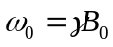 (2)
where ω₀ is called the Larmor frequency. This equation, called the Larmor equation, is the basis for nuclear magnetic resonance and MRI.
To describe the collective behavior of a spin system in an external magnetic field, a macroscopic magnetization vector M is introduced, which is the vector sum of all microscopic magnetic moments in the object. The magnitude of the magnetization is proportional to the total number of spins in the object being imaged. When a nucleus with net spin is placed in an external magnetic field, quantum mechanically, there is a low-energy and a high-energy state depending on the two possible spin orientations with respect to the field axis at a given time. In this case, the z component of the magnetic moment is either +½γh or -½γh, where h = 6.626x10⁻³⁴ J s is Plank's constant. Each nucleus can undergo a transition between the two energy states by the absorption of RF energy. The energy difference between the two spin states is related to the Larmor frequency as
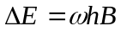 (3)
At room temperature, the number of spins in the lower energy level slightly outnumbers the number in the upper level, which leads to a measurable macroscopic net magnetization in z direction. The x-and y-components are zero because the projection of the individual nuclear magnetic moments onto the transverse plane has a random phase while it precesses about the z-axis. Therefore, the bulk magnetization vector points exactly along the positive direction of the z-axis at equilibrium, and its magnitude is proportional to the strength of the B field and the number of spins in the system.

RF Excitation and Resonance
As mentioned above, without any disturbance the transverse component of the macroscopic magnetization is zero. Establishment of a measurable transverse component of M is called spin resonance. In order to produce and detect a MRI signal, the magnetization vector must first be tipped away from the external field direction (z) in order to set it into precession. This is accomplished by moving some of the nuclei to the higher spin energy state. The global magnetization vector produced by the proton spins will also precess yielding a rapidly changing magnetic field flux in the nearby receiver coil. To induce a coherent transition of spins from one energy state to another, the frequency of the RF radiation must be equal to the Larmor frequency, which is known as the resonant condition. In MRI, the external energy to produce resonance comes from an RF-oscillating magnetic field, which is perpendicular to the static B₀ field and is usually applied in x-direction in form of short RF pulses.
Once the magnetization has a transverse component, it is possible to detect its precession about the z-axis with the Larmor frequency using the receiver coil. Due to dephasing of the spin precession, the signal will exponentially fall to zero with a time constant called T₂. An electromotive force (emf) is created in that coil as a consequence of Faraday’s induction law. The emf generates a current signal in the coil, which is measured and contains all the information necessary to form the image of the object.

Principle of Spatial Localization with Gradient Fields and Frequency Encoding
In MRI, we want to image the spin density distribution ρ(x, y, z) of the object based on the measurement of the MRI signal as function of time. In general terms, this accomplished by connecting the spin precession frequency to its position and then by deriving the spatial distribution of the spin density by performing a Fourier transform (see below for more details).
The Larmor frequency of the spins will be linearly related to their position z when the static field is superimposed with a linear gradient field. We assume that the magnetization vector has been tipped into the transverse plane initially and is already precessing freely with an angular frequency ω₀ when the gradient field in z direction is turned on. After that the z-component of the magnetic field is
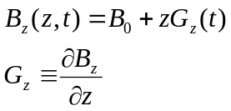 (4)
The time dependence of G_{z} reminds us that the gradient field is not on the whole time. The frequency distribution of the spins in the object is therefore
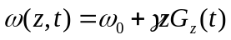
The use of a gradient field to establish a relationship between the position of spins along some direction and their precession frequency is called frequency encoding along that direction. The frequency encoding direction is also called the read direction.
The accumulated phase, up to a time t after turning on the gradient at t = 0, is
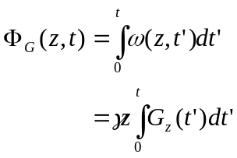 (5)

One-Dimensional Imaging Equation, Fourier Transform, and k-Space
Ignoring the T₂ decay of the MRI signal, the signal of the RF detector coil is proportional to the sum of all sinusoidal oscillations weighted by the spin density:
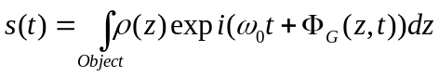 (6)
where ρ(z) is a quantity that is proportional to the one-dimensional spin density profile.
After demodulation of the time signal (removing its high-frequency component) it becomes only dependent on the gradient field. When the gradient G_{z} is constant during the sampling interval, we may write
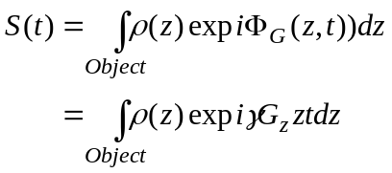 (7)
We may now introduce the spatial frequency k sampled at time t as
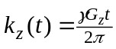 (8)
so we can write
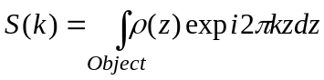 (9)
where the integral extends over the volume with non-zero spin density (the “Object”). This equation is fundamental to MRI since it shows that by sampling the k-space (in time) one can derive a signal that is the Fourier transform of the spatial density profile. The foremost property of the Fourier transform is its well-defined inverse. Given S(k) for the entire k-space, the spin density of the object can be found by taking the inverse Fourier transform of the signal
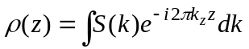 (10)
The signal S(k) and the image ρ(z) are a ‘Fourier transform pair.’ It is important to note that the frequency encoding direction is not limited to the z-direction and any other direction can be chosen. Most commonly in MRI, frequency encoding is along the x-direction.
It is very useful to formulate imaging arguments in terms of image (z) space and data (k) space, in view of their Fourier transform connection. The existence of the inverse transform means that the spin density profile along a direction can be reconstructed from the signal if the latter is collected over a sufficiently wide range of k values. To collect a uniform distribution of points in k-space, it is only necessary to sample the signal at a constant rate in the presence of a constant gradient. Sampling both positive and negative values for k can be achieved by changing the sign of the gradient.
However, several factors prevent collection of continuous data over all k-space. First, the signal must be sampled at discrete intervals in a finite amount of time and second, relaxation effects will diminish the signal below noise level within a finite period. Data collected will, therefore, be a truncated and discrete version of S(k), and it is necessary to study the discrete Fourier transform to understand the impact of these modifications on the resulting image. This is beyond the scope of this summary and not important for understanding the effect of gradient nonlinearities.

The 3D Imaging Equation
We now extend the 1D imaging equation to all three spatial dimension, at first, without consideration how the image is to be viewed or presented. The signal from the RF excitation of the whole sample in the presence of three orthogonal gradients G_{x}, G_{y}, and G_{z}, may be written as the 3D-Fourier transform
(11)
where the three components of the time-dependent k-vector are related to the gradients as
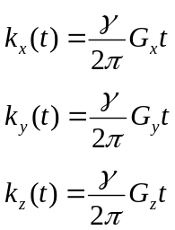 (12)
where t runs from the onset of the gradient. The challenge of multidimensional MRI imaging is to manipulate the gradients in such a way that 3D k-space can be sampled sufficiently in order to reconstruct the 3D spin density distribution from the inverse Fourier transformation.

2D Image Representation
For imaging of a thin slice through a 3D object, only k_{x} and k_{y} need to be sampled. An appropriate sequence can be designed to cover 2D k-space with a set of discretely sampled lines as shown in Fig. 2 below. This is obtained by alternately turning on the G_{x} gradient and then the G_{y} gradient for a time period τ_{y}. Each set of points along a given k_{y} line represents the acquisition of a ‘phase encoded’ 1D data set, with the phase at each sample point encoded as 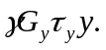This y-dependent phase contribution is unchanged during 1D data sampling along the k_{x} -axis.
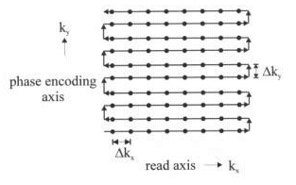
Fig. 2. The k-space coverage for a 2D image. Each dot represents a sample point. Lines of connected dots are sampled k-points in read direction during the same read period. The arrows indicate the chronological order of the 2D data acquisition.

3D Coverage: 3D Imaging versus Multi-sice 2D Imaging
The coverage of 2D k-space described above can be generalized to 3D by considering a series of planes leading to a three-dimensional set of parallel lines. The set can be obtained in 3D k-space by discrete sampling, or phase encoding, in both of the directions ky and kz. The imaging of three dimensions by the use of two phase encoding directions perpendicular to the read direction is called ‘3D imaging,’ to contrast it with ‘multi-slice 2D imaging.’ The difference between the two approaches has to do with how the RF excitation is carried out. In true 3D imaging, an RF pulse is used to excite a thicker slab which is then phase encoded (or as it is called ‘partition encoded’) in the slice select gradient direction; a series of such RF pulses is applied to run through all the partition encoding values. As before the sampling along the read direction is carried out with measurements at finite time steps Δt during the continuous application of gradient G_{x}. The associated step in the k_{x} direction is
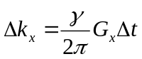 (13)
The orthogonal phase encoding gradients, G_{y} and G_{z}, are turned off during read sampling, in order to keep each sampling line parallel t the x-axis. Before the read data are taken, the (kx, ky) position of each line is determined by applying the orthogonal gradients for, say, times τ_{y} and τ_{z}. After a given line has been sampled, an adjacent parallel line is approached by turning the orthogonal gradients back on, for the same times τ_{y} or τ_{z}. and with the same amplitudes. The corresponding shifts in k-space are
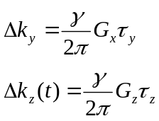 (14)
In 2D multi-slice imaging, the application of a finite bandwidth radiofrequency RF excitation centered at the Larmor frequency of the combined static field plus a gradient field leads to the excitation of a thin slice of spins orthogonal to that gradient with slice thickness d (see Fig. 3). Slices can be selected in any orientation by employing different configurations of gradient coils.
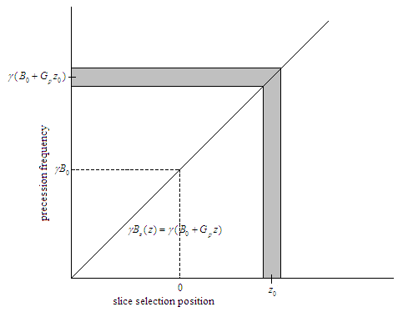
Fig. 3 The principle of MRI slice selection. The precession frequency ω in the laboratory frame is a function of position along the slice selection axis in 2D MRI imaging. During excitation of the selected slice, the original static field B₀ is superimposed with a field with constant gradient G_{z} in the z-direction. The central frequency and spectral bandwidth of the RF pulse Δω are such that the slice of thickness Δz is uniformly excited. The fact that the slice is offset from the origin in the z direction by z₀ implies that the center frequency of the RF pulse must be offset from the static Larmor frequency ω₀ = γB₀ by γG_{z}z₀ as shown along the frequency axis.

3. Gradient Field Nonlinearities as a Warping Transformation

Origin and Manifestations
As described above, spatial indexing in MRI is accomplished by gradient coils in three orthogonal directions. In image reconstruction, gradients are assumed linear throughout the imaging volume. Due to pragmatic constraints, further considered below, it is difficult to achieve this situation.
For a patient to fit comfortably, the bore of the main magnet must be as large as possible. The larger the bore, the more difficult it is to generate a linear gradient. In general, the gradient along the axis of the main magnet (z axis) has the highest linearity compared to the other two directions (x and y) due to physical constraints.
Consider a slice of constant z, read in x direction. In the slice image, gradient field non-linearity distortion manifests itself in two ways. First, due to non-linearities in the x gradient, G_{x}, and in the y-gradient, G_{y}, there is a systematic transverse distortion in the slice plane. Second, because of the gradient field non-linearity, a potato chip effect takes place along the slice selection direction (z). Although MRI slices are usually considered to be planes, in actuality, because of gradient field non-linearity, these planes tend to warp into a “potato chip-like” shapes. This distortion is difficult to correct in 2D imaging but can be, in principle, corrected in 3D imaging methods.

Mathematical Description of the Distortion in One Dimension
Any field variation in addition to the assumed linear gradients, which is present during frequency encoding, causes spins to be spatially encoded at the wrong position. The incorrect spatial localization of a spin during frequency encoding is generally referred to as image distortion.
Consider the 1D imaging example from before using x as the readout direction. We now assume that in addition to the linear gradient in x direction, there is a background gradient distortion which is nonlinear in x.
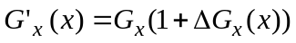 (15)
In this case, the accumulated phase at time t becomes:
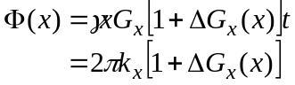 (16)
This equation implies that the spins residing at position x will be encoded at position x’ in the reconstructed image, where
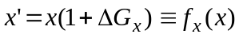 (17)
Substituting the modified gradient field into the 1D imaging equation, the k-domain signal becomes:
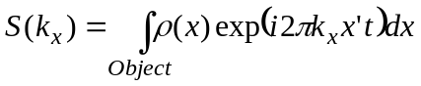 (18)

After changing the variable of integration from x to x’, the imaging equation can be written as
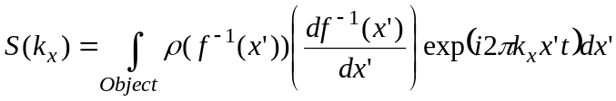 (19)
With the substitution:
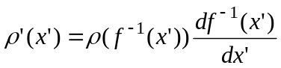 (20)
this can be written in the form of an ordinary Fourier transformation:
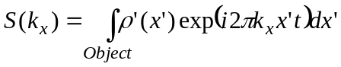 (21)
After reconstruction, the recovered object spin density profile is not the original profile but the distorted one. Therefore, the non-linearity in x’ leads to a distorted spin profile that also has an intensity different from the original spin profile.

4. Further Details on Physics and Mathematics of Gradient Nonlinearity Distortion

The Gradient Coils
Misregistration caused by gradient field non-linearities occur in all three directions. The magnetic fields generated by the three gradient coils and the main magnet lie along the z-axis. Due to the strength of the main B₀ field, any other component of the gradient fields can be neglected.
The z-gradient coil is designed to produce a linear variation in the z-component of the field along the axis of the magnet, with a high degree of gradient uniformity in the transverse plane. Circular wire loops are the most obvious choice since they are azimuthally symmetric and possess reasonable radial uniformity. Since the gradient fields have to be symmetric with respect to the gradient isocenter, the coils are usually arranged as pairs. For the z-gradient, the current in the coil pair, called Maxwell pair, is equal in magnitude, but opposite in direction (see Fig. 4). Coils on one side of the z = 0 plane generate fields parallel to B₀ while fields due coils on the other side are anti-parallel to B₀ leading to an overall field variation along z. The relation between the radius a of the coils and their axial distance d is optimized in order to minimize all but the linear z-term in the polynomial expansion of the field described below.
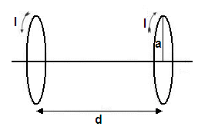
Fig. 4. Principal design of a Maxwell pair of coils generating the z-gradient field.

The design of the gradient coils in x and y-direction is more complicated. The principle design, called Golay arrangement, is shown in Fig. 5. The x- and y-gradient coils are identical except for a rotation by 90 degrees.
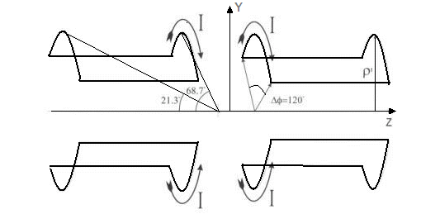
Fig. 4. Golay arrangement of a coils producing a y-gradient. Note that the field direction coincides with the z axis.

Physical and Mathematical Description of Nonlinear Gradient Fields
Let B the magnetic flux density and H be the magnetic field intensity vectors produced by any of the gradient coils. The relationship between these vector quantities is
B = μ H
where μ is the permeability of the medium. Gradient fields are usually quasistatic (slowly varying in time) magnetic fields, therefore, displacement currents in the medium inside the coil may be ignored unless very rapid sequences are used. Electromagnetic field theory tells us that a quasistatic magnetic field in a current free region can be described by a scalar magnetic field potential ψ such that
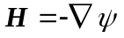 (22)
A fundamental property of magnetic fields is that its divergence is always zero, thus 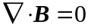everywhere, and therefore the scalar magnetic potential satisfies Laplace’s equation:
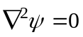 (23)
It can be shown that solutions of Laplace’s equation can be expressed as linear combinations of homogeneous polynomials in the coordinates x, y, z. In order to describe the nonlinearity of a gradient field, one usually decomposes the field into the ideal linear term and additional nonlinear field terms; the latter are expanded into homogenous polynomials. Furthermore, if one assumes circular symmetry, which means that there is no specific angular dependence of the nonlinear field terms, one obtains following general expressions for the three gradient fields B^{(x)}, B^{(y)}, and B^{(z)}
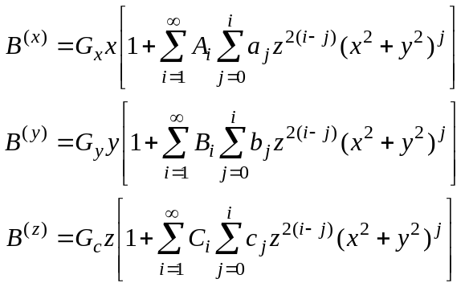 (24)
Note that if the nonlinear terms vanish, the gradient fields become perfectly linear. In general, the higher order polynomials in these field equations are insignificant (contribute very little to the field) and can therefore be ignored. In practice, it is sufficient to include only polynomials up to the second order i = 2 in x², y², and z². Thus, the field gradient expressions become
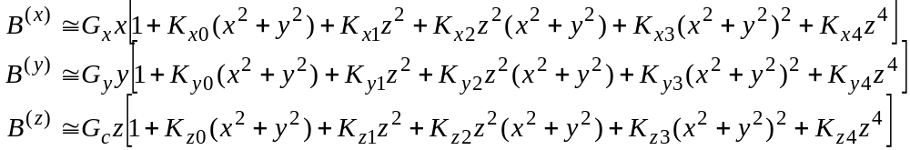 (25)
where we have introduced new constants K (for example, K_{x0} = A₀ a₀). By comparing equation (25) with equation (17) one can see that the coordinate distortion functions f_{x}(x, y, z) can be expressed as
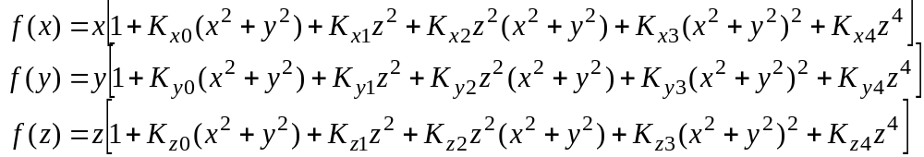 (26)
Equation (26) can be conveniently written in matrix form as
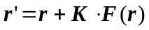 (27)
where r’ is the distorted coordinate vector derived from the undistorted vector r, K is the distortion parameter matrix formed by the elements K_{α,i} , α = x, y, z, i = 0,1,..4, and F(r) is a nonlinear six-dimensional vector field given by
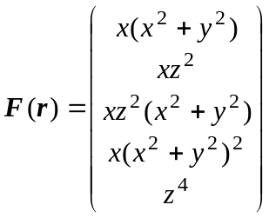 (28)

5. Inversion of the Distortion Transformation
still to come…

References
- T. S. Sumanaweera. Segmentation and distortion correction in medical imaging. Doctoral dissertation. Department of Electrical Engineering, Stanford University, 1992.
- E. M. Haacke Magnetic Resonance Imaging: Physical Principles and Sequence Design. John Wiley & Sons, 1999 (available at Amazon.com)
- Z.-P. Liang and P. C. Lauterbur. Principles of Magnetic Resonance Imaging: A Signal Processing Perspective. IEEE Press Marketing, 2000.
- http://www.cis.rit.edu/htbooks/mri/index.html
- http://books.nap.edu/books/0309053870/html/index.html

A homogeneous polynomial is a multivariate polynomial (i.e., a polynomial in more than one variable) with all terms having the same degree. For example, x³ + xyz + y²z + z³ is a homogeneous polynomial of degree three. (definition given in http://mathworld.wolfram.com/HomogeneousPolynomial.html)

